Asia-China-Coin-Flat Handled Spade Money-Type 5, Three Hole Spades-Currency Money Model

Asia-China-Coin-Flat Handled Spade Money-Type 5, Three Hole Spades 三孔布Sān kǒng bù, Currency Money Model-桥 形 币钱 范, Qiáo xíng Bì qián Fàn

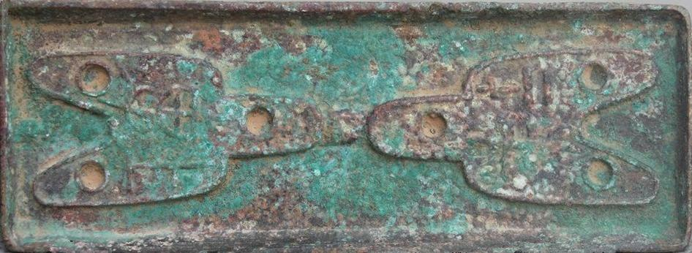 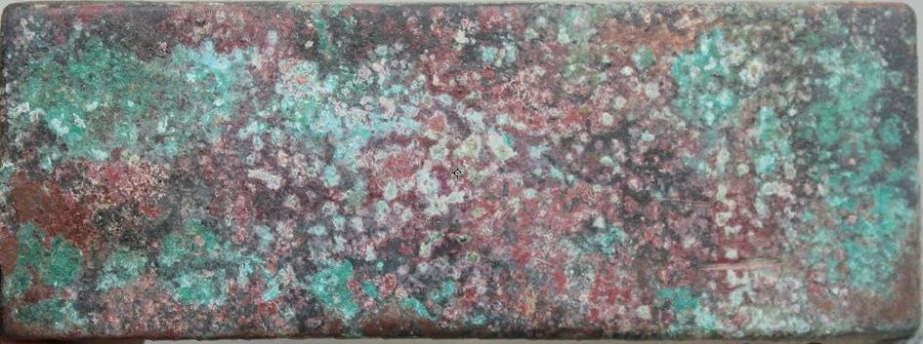

Flat Handled Spade Money-Type 5, Three Hole Spades 三孔布Sān kǒng bù, Currency Money Model-桥 形 币钱 范, Qiáo xíng Bì qián Fàn. Harthill 3.486 Obv: 下甫 *XiaPu.* Height 4.5 cm., width 11.5 cm.

Holes in the handle and feet. Round handle, round shoulders, and round feet.

Two sizes are found. The large size has the inscription *Liang* on the reverse; the smaller *Shi er zhu* (12 *zhu).* As the *liang* unit of weight was divided into 24 *zhu,* clearly the two sizes rep­resent denominations of a "one" and of a "half'. They also have series numbers on the handle on the reverse. Like the Round Foot Spades, it is not definitely established which State issued them. Their find spots are in eastern Shanxi and Hebei.

The mint names are cities that were occupied by both Zhong Shan and Zhao.

All coins of this type are exceedingly rare. This Money Model or cast is in this category.

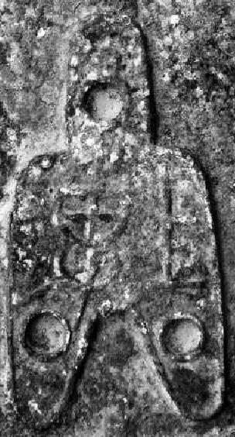 SHAPE \\* MERGEFORMAT 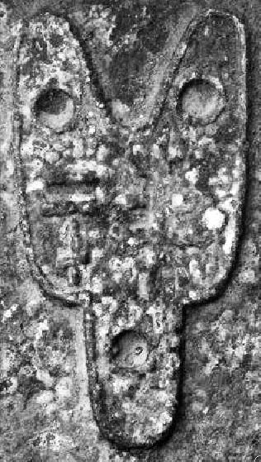

Detail Flat Handled Spade Money-Type 5, Three Hole Spades 三孔布Sān kǒng bù, Currency Money Model-桥 形 币钱 范, Qiáo xíng Bì qián Fàn. Cf. Harthill 3.486. Left: Obverse, Right: Reverse, Similar to Harthill 3.485. Rarity 0.